Revised Agency Review Draft

Dude Creek Critical Habitat Area
Plan

by
Division of Habitat
and
Division of Wildlife Conservation

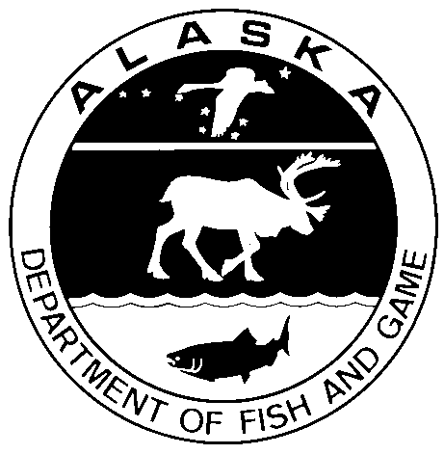

May 2013
Alaska Department of Fish and Game Divisions of Habitat and Wildlife Conservation

Symbols and Abbreviations
The following symbols and abbreviations, and others approved for the Système International d'Unités (SI), are used without definition in the following reports by the Divisions of Sport Fish and of Commercial Fisheries: Fishery Manuscripts, Fishery Data Series Reports, Fishery Management Reports, and Special Publications. All others, including deviations from definitions listed below, are noted in the text at first mention, as well as in the titles or footnotes of tables, and in figure or figure captions.

Weights and measures (metric)
centimeter cm
deciliter dL
gram g
hectare ha
kilogram kg
kilometer km
liter L
meter m
milliliter mL
millimeter mm

Weights and measures (English)
cubic feet per second ft³/s
foot ft
gallon gal
inch in
mile mi
nautical mile nmi
ounce oz
pound lb
quart qt
yard yd

Time and temperature
day d
degrees Celsius °C
degrees Fahrenheit °F
degrees Kelvin K
hour h
minute min
second s

Physics and chemistry
all atomic symbols
alternating current AC
ampere A
calorie cal
direct current DC
hertz Hz
horsepower hp
hydrogen ion activity pH
(negative log of)
parts per million ppm
parts per thousand ppt,
‰
volts V
watts W
General
Alaska Administrative
Code AAC
all commonly accepted
abbreviations e.g., Mr., Mrs., AM, PM, etc.
all commonly accepted
professional titles e.g., Dr., Ph.D.,
R.N., etc.
at @
compass directions:
east E
north N
south S
west W
copyright ©
corporate suffixes:
Company Co.
Corporation Corp.
Incorporated Inc.
Limited Ltd.
District of Columbia D.C.
et alii (and others) et al.
et cetera (and so forth) etc.
exempli gratia
(for example) e.g.
Federal Information
Code FIC
id est (that is) i.e.
latitude or longitude lat. or long.
monetary symbols
(U.S.) $, ¢
months (tables and
figures): first three
letters Jan,...,Dec
registered trademark ®
trademark ™
United States
(adjective) U.S.
United States of
America (noun) USA
U.S.C. United States Code
U.S. state use two-letter abbreviations (e.g., AK, WA)
Measures (fisheries)
fork length FL
mideye-to-fork MEF
mideye-to-tail-fork METF
standard length SL
total length TL

Mathematics, statistics
all standard mathematical
signs, symbols and
abbreviations
alternate hypothesis H_{A}
base of natural logarithm e
catch per unit effort CPUE
coefficient of variation CV
common test statistics (F, t, χ², etc.)
confidence interval CI
correlation coefficient
(multiple) R
correlation coefficient
(simple) r
covariance cov
degree (angular ) °
degrees of freedom df
expected value E
greater than >
greater than or equal to ≥
harvest per unit effort HPUE
less than <
less than or equal to ≤
logarithm (natural) ln
logarithm (base 10) log
logarithm (specify base) log_{2,} etc.
minute (angular) '
not significant NS
null hypothesis H_{O}
percent %
probability P
probability of a type I error
(rejection of the null
hypothesis when true) α
probability of a type II error
(acceptance of the null
hypothesis when false) β
second (angular) "
standard deviation SD
standard error SE
variance
population Var
sample var

Revised agency review draft

dude creek CRITICAL HABITAT AREA
Plan

Prepared by

Alaska Department of Fish and Game
333 Raspberry Road, Anchorage, Alaska 99518-1599

Prepared by the Divisions of Habitat and Wildlife Conservation
Alaska Department of Fish and Game
Anchorage, Alaska

This document is a draft, and should not be cited.

The Alaska Department of Fish and Game (ADF&G) administers all programs and activities free from discrimination based on race, color, national origin, age, sex, religion, marital status, pregnancy, parenthood, or disability. The department administers all programs and activities in compliance with Title VI of the Civil Rights Act of 1964, Section 504 of the Rehabilitation Act of 1973, Title II of the Americans with Disabilities Act (ADA) of 1990, the Age Discrimination Act of 1975, and Title IX of the Education Amendments of 1972.
If you believe you have been discriminated against in any program, activity, or facility please write:
ADF&G ADA Coordinator, P.O. Box 115526, Juneau, AK 99811-5526
U.S. Fish and Wildlife Service, 4401 N. Fairfax Drive, MS 2042, Arlington, VA 22203
Office of Equal Opportunity, U.S. Department of the Interior, 1849 C Street NW MS 5230, Washington DC 20240
The department’s ADA Coordinator can be reached via phone at the following numbers:
(VOICE) 907-465-6077, (Statewide Telecommunication Device for the Deaf) 1-800-478-3648, (Juneau TDD) 907-465-3646, or (FAX) 907-465-6078
For information on alternative formats and questions on this publication, please contact:
ADF&G, Sport Fish Division, Research and Technical Services, 333 Raspberry Road, Anchorage AK 99518 (907)267-2375.

ACKNOWLEDGEMENTS
The Dude Creek Critical Habitat Area Plan has been prepared by Alaska Department of Fish and Game biologists Mark Fink and Tammy Massie (Division of Habitat), and Neil Barten and Ryan Scott (Division of Wildlife Conservation). This plan was developed with the aid of an interagency planning team composed of representatives from state, federal, and local agencies with jurisdiction over the critical habitat area and critical habitat area resources:
Charles Pinckney, Alaska Department of Natural Resources
Morgan Deboer and Paul Berry, City of Gustavus
Hank Lentfer, The Nature Conservancy
Ben Grussendorf, Alaska Board of Game (Soon after the release of this draft plan, we learned of Ben’s death on June 1, 2011. Ben served as the Board of Game liaison on the planning team, and his input into this plan was invaluable. We are grateful to Ben for his assistance on this plan, and for the many years he spent on the Board of Game working to provide hunting opportunities for the public while conserving Alaska’s wildlife populations.)
Tania Lewis and Lewis Sharman, National Park Service
Neil Barten and Ryan Scott, Alaska Department of Fish and Game, Division of Wildlife Conservation
Kristy Tibbles, Alaska Department of Fish and Game, Boards Support
Brian Glynn and Jason Cheney, Alaska Department of Fish and Game, Division of Sport Fish
Mark Fink, Tammy Massie, and Katie Eaton, Alaska Department of Fish and Game, Division of Habitat
Other Alaska Department of Fish and Game staff contributors were:
Mike Petrula, Division of Wildlife Conservation
Frances Inoue and Jason Graham, Division of Sport Fish provided GIS and cartographic support
Other Alaska Department of Natural Resources staff contributors included Rich Vanderhoek (State Historic Preservation Office).
A number of individuals represented themselves and various organizations at scoping meetings. Greg Streveler shared his long-term knowledge of the biological resources of the area. Kapryce Manchester assured that we had a meeting space for each of our planning team meetings. We especially want to thank the city and tribal administrators and residents of Gustavus and Hoonah for their contributions to the scoping process.
Partial funding for this project was provided through an Alaska State Wildlife Grant (SWG). The SWG program is funded by annual Congressional appropriations that are administered by the United States Fish and Wildlife Service.

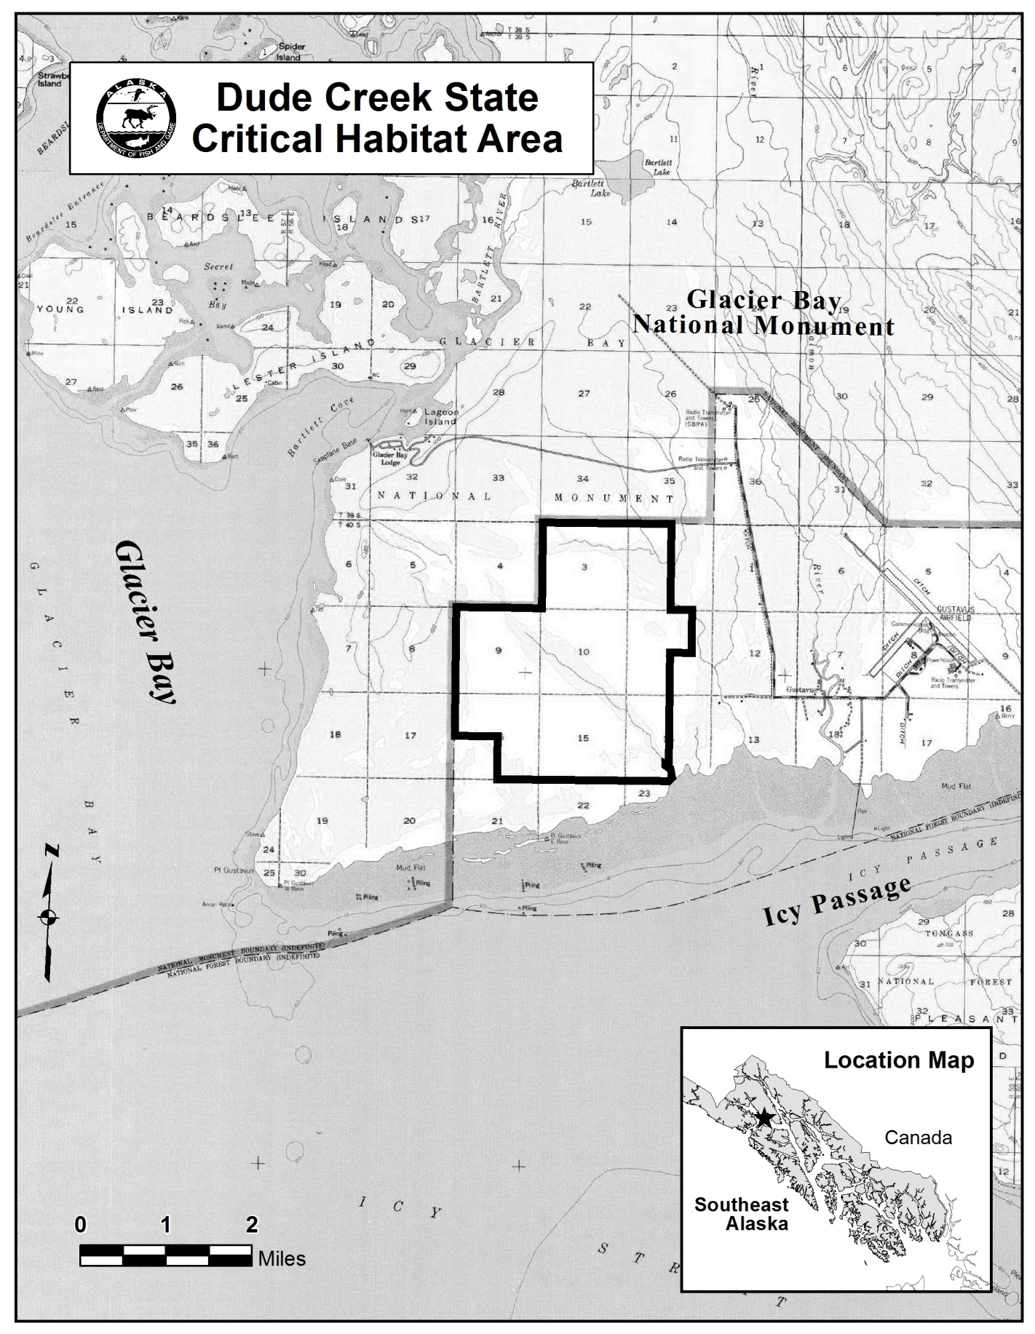
Figure 1.–Map of Dude Creek Critical Habitat Area.

introduction
In 1988 (§ 1 ch 31 SLA 1988) the Alaska Legislature established the Dude Creek Critical Habitat Area (CHA) to protect and enhance wet meadow habitats for lesser sandhill cranes (Grus canadensis) and for the continued public use and enjoyment of the area. The legislative intent prioritized habitat protection over public use of the CHA. The CHA is located on the Gustavus Forelands in Southeast Alaska, west of the community of Gustavus, and abuts the Glacier Bay National Park and Preserve. Dude Creek CHA encompasses about 4,082 acres of open wetlands graduating to scrub pine and spruce forests.
Dude Creek CHA is managed by the Alaska Department of Fish and Game (ADF&G) in accordance with Alaska Statute 16.20.520-530. The purpose of the Dude Creek Critical Habitat Area Plan is to provide consistent, long-range guidance to ADF&G Division of Habitat biologists in authorizing activities within the CHA.
This draft plan presents goals for the CHA, and identifies policies to be used in providing guidance for whether proposed activities are compatible with the protection of fish and wildlife, their habitats, and public use of the CHAs. The goals and policies of this plan are adopted as regulation.
This draft plan affects state lands and waters. There are no private or federal lands within the boundary of the CHA. Furthermore, the plan does not address hunting or fishing regulations, which are the authority of the Alaska Boards of Fisheries and Game.

The Planning Process
This plan is the result of a public planning process led by ADF&G. It was developed by a planning team representing state, federal, and local entities; a) the State of Alaska Departments of Fish and Game and Natural Resources; b) the National Park Service; c) the community and City of Gustavus; and d) The Nature Conservancy.
ADF&G initiated the effort by holding public scoping meetings in Gustavus, Hoonah, and Juneau to explain the planning process and solicit citizens’ issues, interests, and concerns for the Dude Creek CHA. The planning team used public input from these meetings to formulate a list of issues to be addressed in the plan. Concurrently, we began collecting and synthesizing information on fish and wildlife populations and their habitats, other natural resources, land ownership, and existing land uses in the vicinity of the Dude Creek CHA. This information, presented in both map and narrative form, comprises the plan’s Resource Inventory (Appendices A and F).
CHA goals and permitting policies for the Dude Creek CHA were developed by the planning team to address the identified issues. All policies were developed with consideration for their ability to meet the formulated goals.
The public review draft was distributed to solicit comments. The revised public review draft of the plan (dated May 06, 2011) was also forwarded to the Board of Game to fulfill the requirements of AS 16.20.610(c) (Please see Appendix F). The Commissioner of the Alaska Department of Fish and Game will adopt the final plan and corresponding regulations for use by the Division of Habitat in permitting activities within the CHA. At that point, the plan will be implemented by ADF&G, Division of Habitat.

Implementation of the Plan
, Future land use activities within the Critical Habitat Area, including those proposed by private individuals, companies, or federal, local or state agencies, will be approved, conditioned, or denied on the basis of their consistency with the permitting policies provided in the plan.
A Special Area Permit is required for any activity that may affect fish and wildlife habitat, including any construction activity, or any activity which disturbs fish or wildlife other than lawful hunting, trapping, fishing, and viewing in a designated state Critical Habitat Area (5 AAC 95). A Special Area Permit application form can be obtained from any ADF&G office or the department Web site (http://www.adfg.alaska.gov/index.cfm?adfg=uselicense.main); the completed application should be submitted to the Division of Habitat Office in Douglas.

Permitting determinations apply only to activities regulated by the Division of Habitat. Other agencies also may have jurisdiction under their respective authorities. Special Area Permit issuance does not relieve an applicant of responsibility to secure other permits, state, federal, or local.
This plan will be reviewed and updated, as appropriate and necessary. Public notification will be provided during the update process.

STATUTES
Alaska statutes that specifically pertain to the establishment and management of the Dude Creek Critical Habitat Area are codified in AS 16.20. The management direction for all state critical habitats, AS 16.20.500, became law in 1972 (§ 2 ch 140 SLA 1972). The enabling legislation for the Dude Creek Critical Habitat Area became law in 1988 (§ 1 ch 31 SLA 1988).

Sec. 16.20.500. Purpose. The purpose of AS 16.20.500 – 16.20.690 is to protect and preserve habitat areas especially crucial to the perpetuation of fish and wildlife, and to restrict all other uses not compatible with that primary purpose.

Sec. 16.20.510. Regulations. The Board of Fisheries and the Board of Game, where appropriate, shall adopt regulations they consider advisable for conservation and protection purposes governing the taking of fish and game in state fish and game critical habitat areas.

Sec. 16.20.520. Multiple land use. Before the use, lease, or other disposal of land under private ownership or state jurisdiction and control, within state fish and game critical habitat areas created under AS 16.20.500 – 16.20.690, the person or responsible state department or agency shall notify the commissioner of fish and game. The commissioner shall acknowledge receipt of notice by return mail.

Sec. 16.20.530. Submission of plans and specifications. (a) When a board determines that the following information is required, it shall instruct the commissioner, in the letter of acknowledgment required under AS 16.20.520, to require the person or governmental agency to submit:
(1) full plans for the anticipated use;
(2) full plans and specifications of proposed construction work;
(3) complete plans and specifications for the proper protection of fish and game; and
(4) the approximate date when the construction or work is to commence.
(b) The board shall require the person or governmental agency to obtain the written approval of the commissioner as to the sufficiency of the plans or specifications before construction is commenced.
Sec. 16.20.610. Dude Creek Critical Habitat Area. (a) The purpose of the Dude Creek Critical Habitat Area is the protection and enhancement of the wet meadow habitat that is the key roosting area for migrating lesser sandhill cranes, for the protection of lesser sandhill cranes, and for the continued public use and enjoyment of the area.

(b) The following described area is established as the Dude Creek Critical Habitat Area:
Township 40 South, Range 58 East, Copper River Meridian
Section 2: W1/2
Section 3
Sections 9 - 10
Section 11: W1/2NE1/4, W1/2
Section 14: Lot 3, NW1/4, N1/2SW1/4, SW1/4SW1/4
Section 15
Section 16: N1/2, SE1/4.

(c) The Dude Creek Critical Habitat Area described in (b) of this section shall be managed under a management plan prepared and implemented by the department in consultation with the community of Gustavus and the Board of Game.

(d) The department shall allow public uses, including fishing, hunting, trapping, mechanized and nonmechanized public access, grazing, firewood harvesting, wildlife viewing, hiking, and berry picking under the management plan adopted under (c) of this section to the extent that the activities are compatible with (a) of this section.

(e) The legislature understands that a portion of the state land described in (b) of this section is mental health trust land of the state and the legislature intends that the land retain its status as mental health trust land, notwithstanding its inclusion in the Dude Creek Critical Habitat Area.

Goals

Special Area Permit decisions authorizing activities occurring within the Dude Creek Critical Habitat Area will be compatible with the following goals in accordance with the purpose for which the area was established (AS 16.20.500). Goals related to fish and wildlife habitat and public use should be given equal standing in interpreting this plan.

Protect habitat for migrating sandhill cranes, especially wet meadow feeding and roosting habitat, and to protect habitat for other naturally occurring resident and migrant fish and wildlife populations.

Minimize harmful disturbance to fish and wildlife, with special attention to sandhill cranes.

Maintain and/or improve public access within the Dude Creek CHA.
Allow public uses when the uses are compatible with the CHA's goals. These uses include: fishing, hunting, trapping, mechanized and non-mechanized public access, grazing, firewood harvesting, wildlife viewing, hiking, and berry picking.

Policies
The policies provided in this plan will be used to guide ADF&G Division of Habitat decisions on Special Area Permits for activities on land and water within the Dude Creek CHA. When reviewing a proposed activity to determine whether a Special Area Permit will be issued, the proposed activity must be evaluated against the applicable goals and policies of the plan. The compatibility policy is always used to evaluate whether a proposed activity is compatible with the purposes for which the critical habitat area was established.
The policies have been evaluated for their ability to meet CHA goals and their effect on major CHA uses and activities. The evaluation of the effects of each policy includes the types and degrees of effect that could reasonably be expected to occur under each policy. . The evaluation of proposed policies includes consideration of six criteria:
Habitat - Will activities authorized pursuant to the proposed policy enhance, damage, or have no effect on habitat values? Will activities authorized pursuant to the proposed policy alter the potential for habitat damage?
Fish and Wildlife Populations - Will activities authorized pursuant to the proposed policy increase, decrease, or not change the potential to maintain species diversity and abundance of fish and/or wildlife, especially sandhill cranes?

Non-consumptive Use of Fish and Wildlife - Will activities authorized pursuant to the proposed policy increase, decrease, or have no effect on the number of user days, type of use, season of use, or quality of non-consumptive use that occurs within the CHA?
Public Access - Will activities authorized pursuant to the proposed policy increase, decrease, or not change the number of user days, type of public access, season of use, or quality of public access that occurs within the CHA?
Public Use, - Will activities authorized pursuant to the proposed policy increase, decrease, or have no effect on public use on CHA lands and waters?

User Conflicts - Will activities authorized pursuant to the proposed policy increase, decrease, or have no effect on user conflicts on CHA lands and waters?

Compatibility
Uses and activities may be allowed in the critical habitat area when the uses and activities are compatible with the purposes for which the critical habitat area was established and with the goals and policies of the plan. Uses and activities will be permitted and conditioned as necessary to: (1) protect sandhill cranes and their habitat, especially wet meadow habitat, and protect other fish and wildlife populations and their habitats, and (2) maintain and/or improve public access within the critical habitat area.

Access
The department will allow public access for continued public use in the critical habitat area. The department may allow improvements to public access within the critical habitat area under terms and conditions of a Special Area Permit.

Roads/ Trails
The department may, on a case-by-case basis, allow the construction of trails in the critical habitat area under terms and conditions of Special Area Permit. The department may, on a case-by-case basis, allow the construction of a road or utility line in the critical habitat area under terms and conditions of Special Area Permit.

Motorized Vehicles
The department may, in its discrection, issue a Special Area Permit for the off-road use of a wheeled, tracked, or other ground effect motorized vehicle (ORV). The terms and conditions of a Special Area Permit may include provisions related to the use of ORVs for habitat enhancement activities and ground conditions.

The department may, in its discretion, issue a Special Area Permit for fixed-wing aircraft and helicopter landings within the critical habitat area.

Camping
A Special Area Permit is not required for non-commercial camping for a duration of 14 days or less at one location.
The department may, in its discretion, issue a Special Area Permit authorizing non-commercial camping activities.

The department may, in its discretion, issue a Special Area Permit for commercial camping in the critical habitat area.
Terms and condition of a Special Area permit may include provisions, as appropriate, for siting camps and associated activities, types of structures, number of camp occupants, access points, period(s) of use, and number of authorized camps within a particular area, and methods to isolate food, garbage, and harvested game and fish from bears and other wildlife. Terms and conditions of a Special Area Permit may also include provisions for the removal of garbage (including solid waste) from the critical habitat area.

Camping Policy Definitions
For the purposes of implementing the camping policy:
“Commercial camping” means the activity is associated with the provision of assistance for compensation, or with the intent to receive compensation, to persons who camp in the critical habitat area.
“Solid waste” means garbage, refuse, abandoned or other discarded solid or semi-solid material, regardless of whether subject to decomposition, originating from any source, not including human waste.

Timber and Firewood Harvest
The harvest of standing dead or downed trees for firewood for use in the critical habitat area does not require a Special Area Permit. The department may, on a case-by-case basis, issue a Special Area Permit for timber harvest or harvest of firewood for use outside the critical habitat area. The terms and conditions of a Special Area Permit my contain provisions related to habitat enhancement.

Fuel and Hazardous Materials Storage
The department may, in its discretion, issue a Special Area Permit for the storage or disposal of hazardous substances or petroleum-based fuels in the critical habitat area. A Special Area Permit is not required for fuel on board vessels, vehicles or aircraft, or for fuel used in an occupied camp (five gallons or less).

Commercial and Group Activities
The department may allow use of the critical habitat area by non-commercial groups of 12 or more persons under terms and conditions of a Special Area Permit. The department, in its discretion, may issue a Special Area Permit for the use of the critical habitat area by commercial groups. The terms and conditions of a Special Area Permit may include provisions related to group size and frequency of trips..
STRUCTURES
The department may allow, on a case-by-case basis, the construction and use of temporary or permanent structures in the critical habitat area, under terms and conditions of Special Area Permit. The terms and conditions of a Special Area Permit may include provisions related to seasonal use of temporary structures, provisions to prevent proprietary or exclusive use by private parties that would interfere with public use opportunities, and provisions for the removal of all solid waste and materials.
. ;

- .

Geological Exploration and Development
The department may , on a case-by-case basis, issue a Special Area Permit for geological exploration and extraction of oil, gas, and coal resources. For the purposes of this policy, geological exploration and extraction includes mining, oil and gas exploration or development, and material extraction.

Habitat Enhancement/Restoration
The department may, in its discretion, issue a Special Area Permit for habitat enhancement projects, particularly for sand hill crane habitat. The Special Area Permit may include conditions addressing the introduction of non-indigenous species to the CHA.

Grazing
The department may, in its discretion, issue a Special Area Permit for grazing in the critical habitat area.

Implementation
The Dude Creek Critical Habitat Area Plan may be implemented by the Alaska Department of Fish and Game, Division of Habitat through Special Area Permits issued for land use activities in the CHA.
Special Area Permits: A Special Area Permit is required for any habitat altering activity, including construction, or any activity which disturbs fish or wildlife other than lawful hunting, trapping, and fishing in the Dude Creek CHA. Project reviews are conducted by Division of Habitat biologists in coordination with other department staff. Division biologists use available supporting scientific data and best professional judgment to determine if a proposed activity will be compatible with the plan; and hence could be permitted. The permitting biologist often reviews similar previously issued permits to maintain consistency. Permitting decisions may be appealed by the applicant through the elevation process (5 AAC 95.920 and AS 46.62.330-630).
A Special Area Permit application form can be obtained from any ADF&G office or from the department’s website at http://www.adfg.alaska.gov/index.cfm?adfg=uselicense.main. The completed application should be submitted to the Division of Habitat office in Douglas (5 AAC 95).

Proposed Changes to 5 AAC 95
Amend 5 AAC 95 by adding a new section to read:

5 AAC 95.62X. Dude Creek Critical Habitat Area Plan. The goals and policies stated in the Dude Creek Critical Habitat Area Plan dated June 30, 2013 are adopted by reference. The plan presents goals and policies for the Dude Creek Critical Habitat Area and its resources that the department will use in determining whether proposed activities in the critical habitat area are compatible with the protection of fish, wildlife, their habitats, and public use of the critical habitat areas. Under 5 AAC 95.420, a special area permit is required for certain activities occurring in a designated state critical habitat area. The department will review each special area permit application for compatibility with the goals and policies of the plan adopted by reference in this section. A special area permit for an activity in the Dude Creek Critical Habitat Area will be approved, conditioned, or denied based on the criteria set out in the goals and policies stated in the Dude Creek Critical Habitat Area Plan and on the standards contained elsewhere in this chapter. (Eff. __, Register __; __/__/2013)

Authority: AS 16.05.020 AS 16.20.520
AS 16.05.050 AS 16.20.530
AS 16.20.500 AS 16.20.610

Amend 5 AAC 95 by adding a new section to read:

5 AAC 95.62X. Dude Creek Critical Habitat Area. (a) The following conditions apply to activities in the Dude Creek Critical Habitat Area:
(1) Off-road use of wheeled, tracked, or other ground-effect motorized vehicles: The off-road use of wheeled, tracked, or other ground-effect motorized vehicles is allowed within the critical habitat area, provided that:
(A) the department may issue an individual special area permit, on a case-by-case basis, for the off-road use of a wheeled, tracked, or other ground-effect motorized vehicle within the critical habitat area if the use is compatible with the goals and policies of the management plan under this section; and compatible with the purpose for which the critical habitat area was established; and
(B) a person must obtain a special area permit before operating an off-road vehicle in the critical habitat area.
(2) Aircraft Access. A person must obtain a special area permit before landing an aircraft in the critical habitat area.
(3) Structures. A person must obtain a special area permit before constructing a structure, including duck blinds, tree stands, or other hardened structure, within the critical habitat area.
(4) Camping. The following conditions apply to camping activities within the critical habitat area:
(A) a person must obtain a special area permit before the camping activity begins to engage in non-commercial camping within the critical habitat area for more than 14 consecutive days at one location;
(B) a person may not provide commercial camping services within the critical habitat area unless authorized by a special area permit issued before providing the services.

(5) Grazing. A person must obtain a special area permit before engaging in grazing activities within the critical habitat.
(6) Fuel storage and hazardous substances. The following restrictions apply to fuel storage and the handling of hazardous substances within the critical habitat area:
(A) a person may not release or dispose of a hazardous substance, or petroleum-based fuel in the critical habitat area;
(B) a person may not store fuel in the critical habitat area unless authorized by a special area permit issued before the activity begins; this condition does not apply to
(i) fuel contained in fuel tanks on board vessels, vehicles, or aircraft;
(ii) fuel actively used in a camp.

(b) In this section,
(1) "commercial camping service" means the provision of assistance for compensation, or with the intent to receive compensation, to persons who camp in the critical habitat area;
(Eff. __, Register___; __/__/2013)

Authority: AS 16.05.020 AS 16.20.550
AS 16.05.050 AS 16.20.555
AS 16.20.500 AS 16.20.560
AS 16.20.520 AS 16.20.565
AS 16.20.530 AS 16.20.570

APPENDIX F:

BOARD OF GAME DOCUMENTATION

Hunting and trapping are considered compatible with the goals of the critical habitat area.

